**Project Report**

**Build an Event Management System using salesforce**

**1. Introduction**

**1.1 Overview**

Event management is the application of project management to the creation and development of small and/or large-scale personal or corporate events such as festivals, conferences, ceremonies, weddings, formal parties, concerts, or conventions. It involves studying the brand, identifying its target audience, devising the event concept, and coordinating the technical aspects before actually launching the event.

The process of planning and coordinating the event is usually referred to as event planning and which can include budgeting, scheduling, site selection, acquiring necessary permits, coordinating transportation and parking, arranging for speakers or entertainers, arranging decor, event security, catering, coordinating with third-party vendors, and emergency plans. Each event is different in its nature so process of planning and execution of each event differs on basis of the type of event.

**1.2 Purpose**

The sole purpose of any event is that a group of people will convene in one particular place for one particular purpose at a given time. Now that could be various purposes such as a wedding, a business networking function, a church gathering, etc. All of which is to come together to explore that purpose.

**2. Problem Definition & Design Thinking**

**2.1 Empathy map**

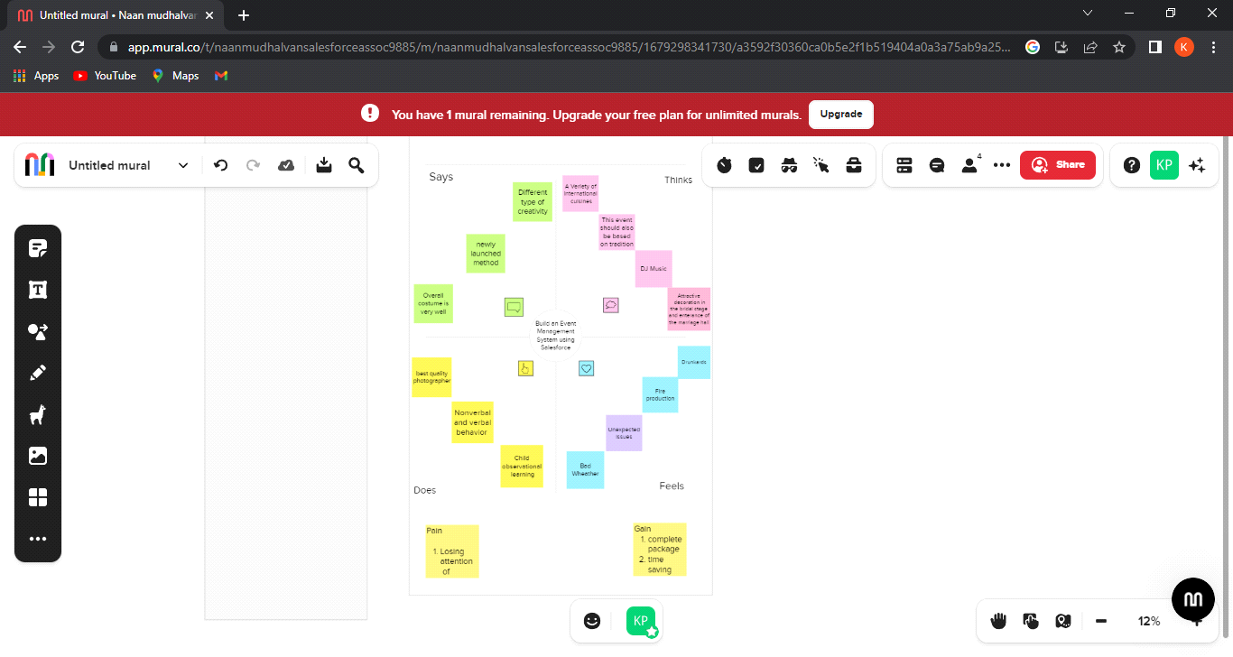

**2.2 Ideation & Brainstorming Map**

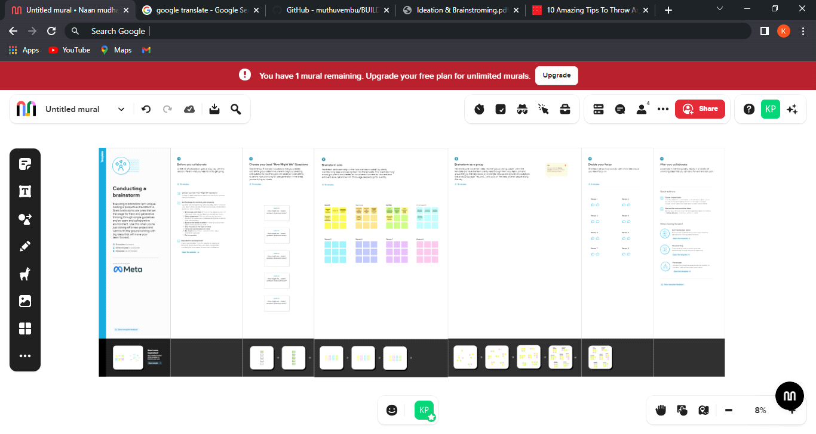

**3. Result**

**3.1 Data Model**

|  |  |
| --- | --- |
| **Object Name** | **Fields in the Object** |
| Event | |  |  | | --- | --- | | Field Label | Data Type | | City | Text | | Start Date | Date/Time | | End Date | Date/Time | |
| Attendee | |  |  | | --- | --- | | Field Label | Data Type | | Id | Auto Number | | Phone | Phone | | Email | Email | | Tickets | Picklist | | Event Name | Master-datail Relationship | |
| Speaker | |  |  | | --- | --- | | Field Label | Data Type | | Bio | Text Area | | e-mail | Email | | Event Name | Look-up Relationship | |
| Vendor | |  |  | | --- | --- | | Field Label | Data Type | | e-mail | Email | | Phone | Phone | | Service Provider | Text | | Event Name | Look-up Relationship | |

**3.2 Activity & Screenshot**

**3.2.1) Object**

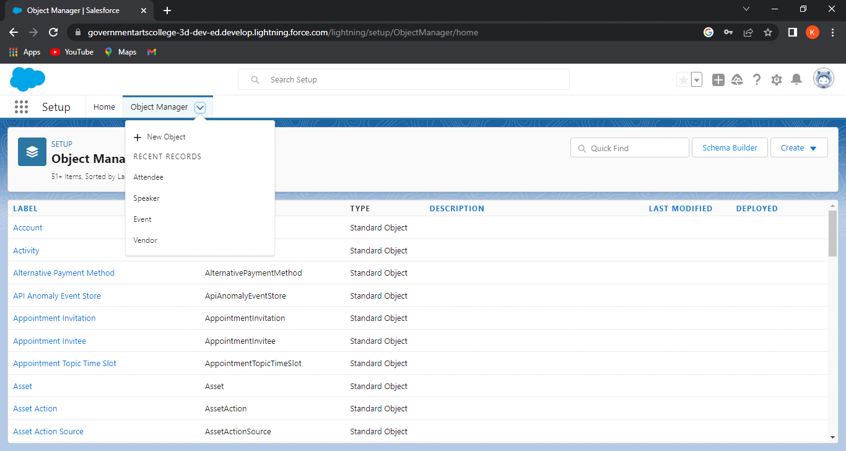

**3.2.2) Tabs**

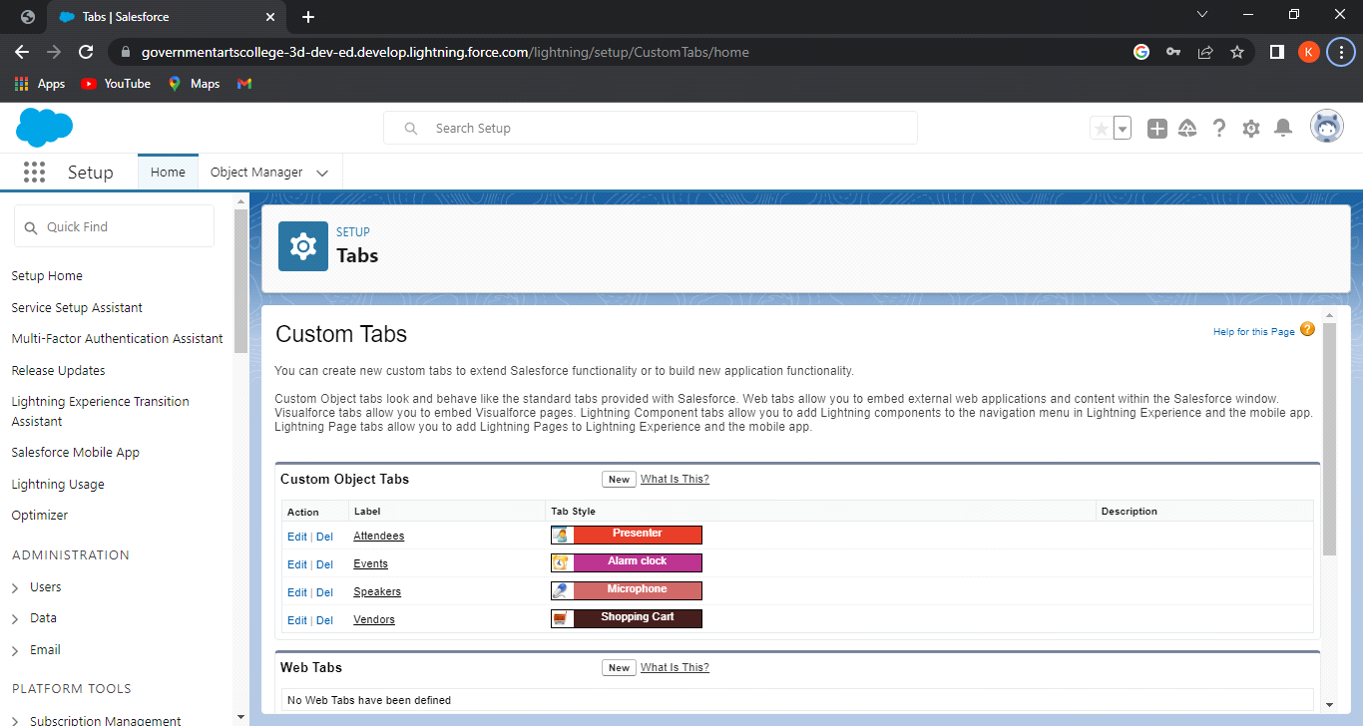

**3.2.3) Application**

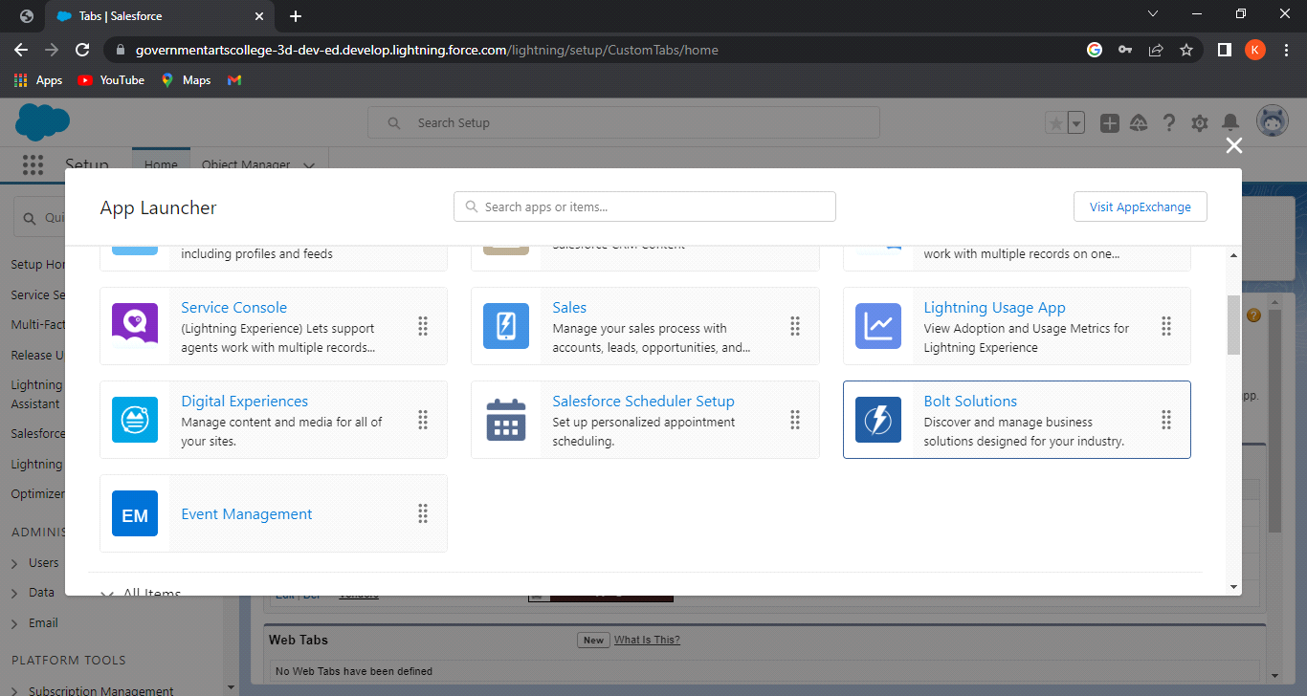

**3.2.4) Fields**

**i) Attendee**

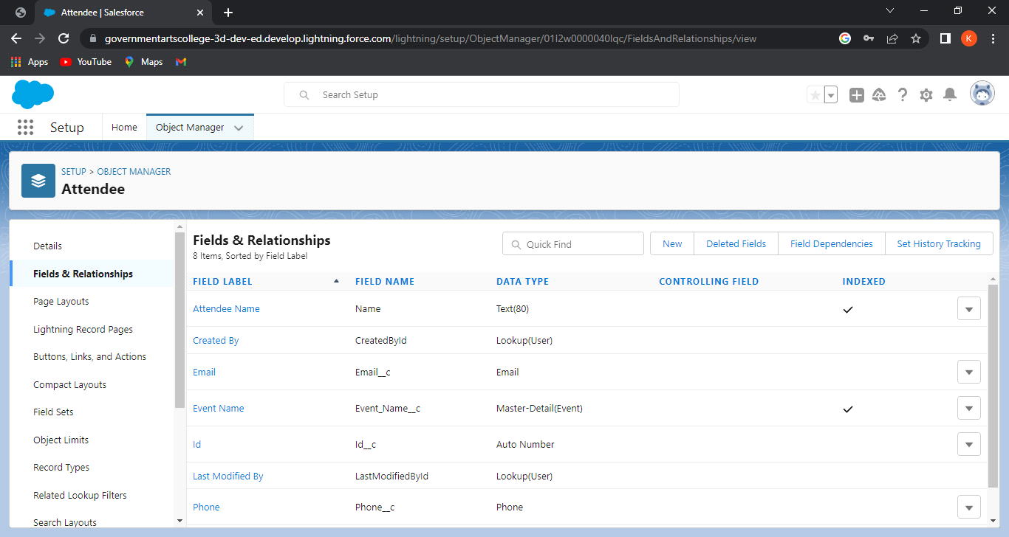

**ii) Event**

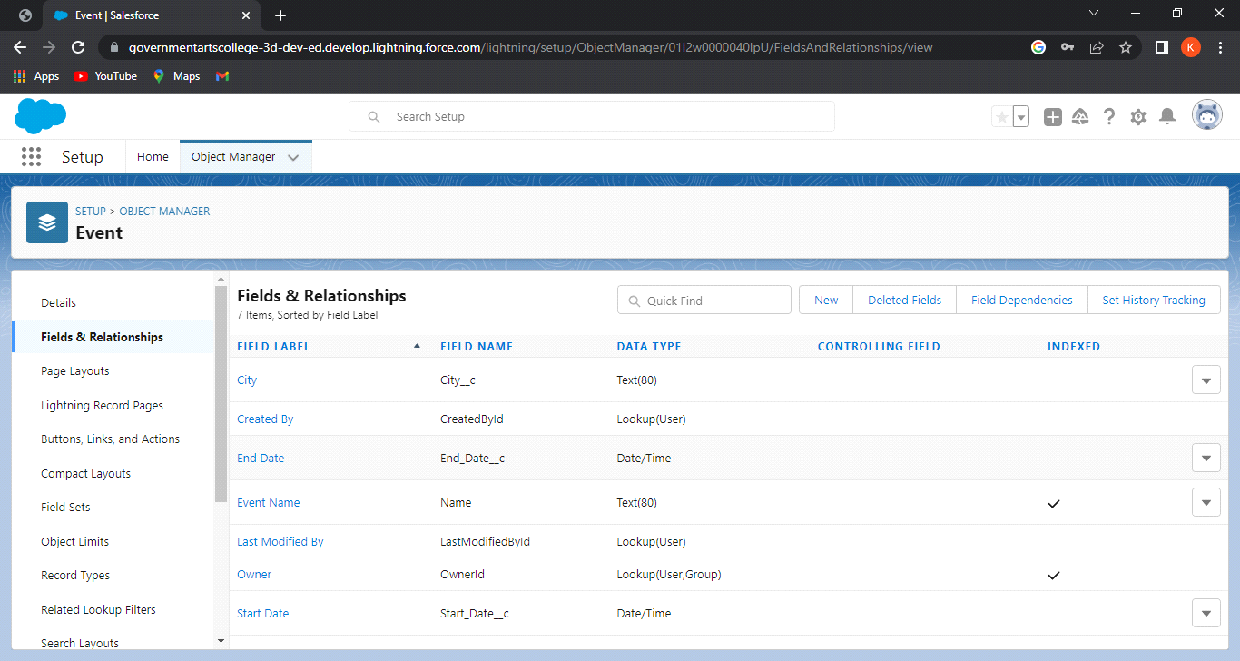

**iii) Speaker**

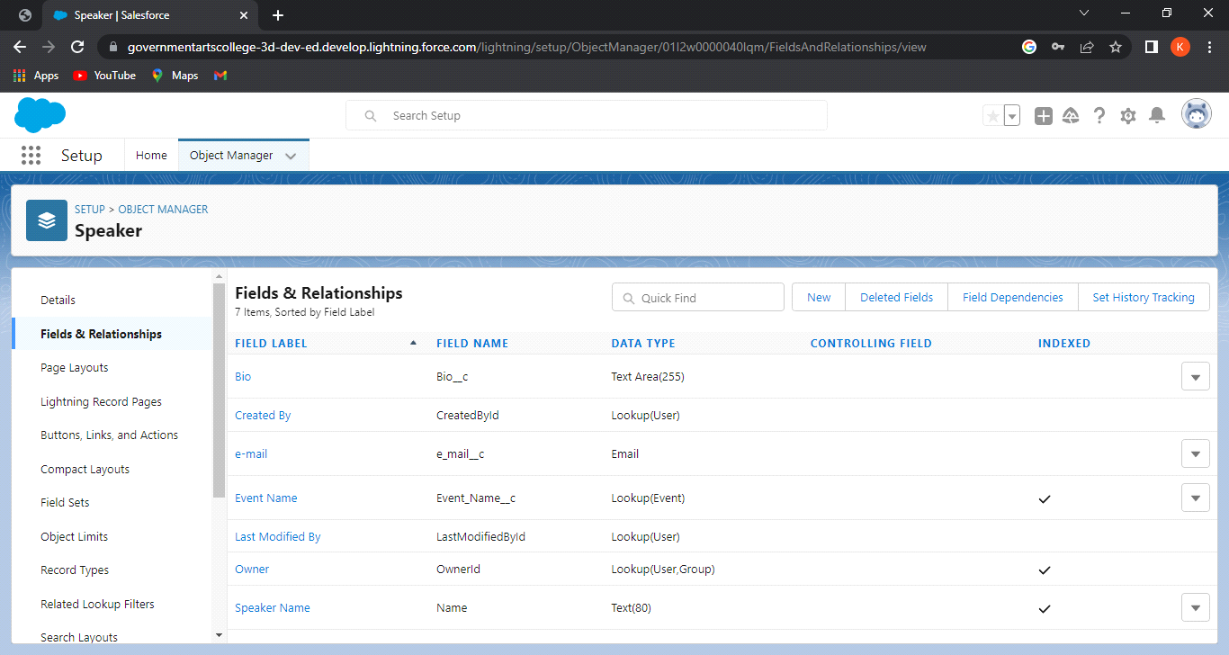

**iv) Vendor**

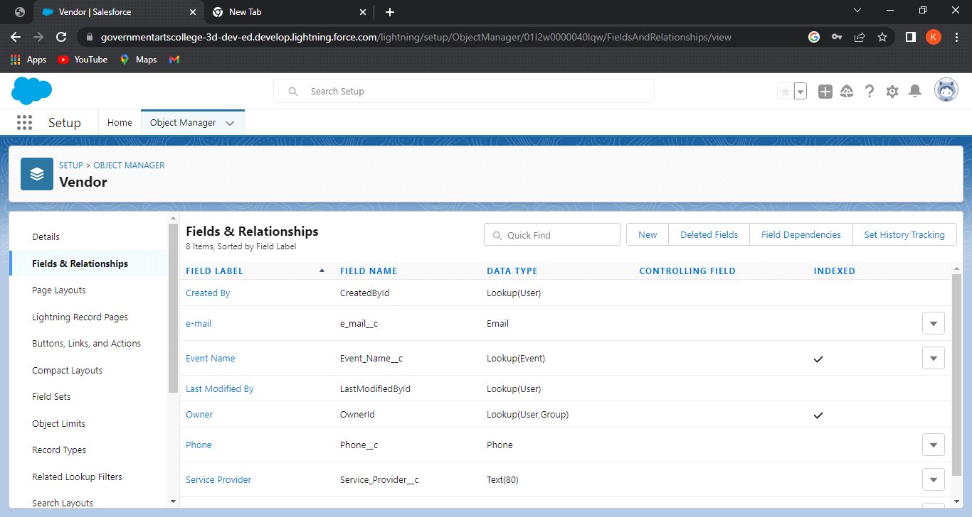

**3.2.5) Profile**

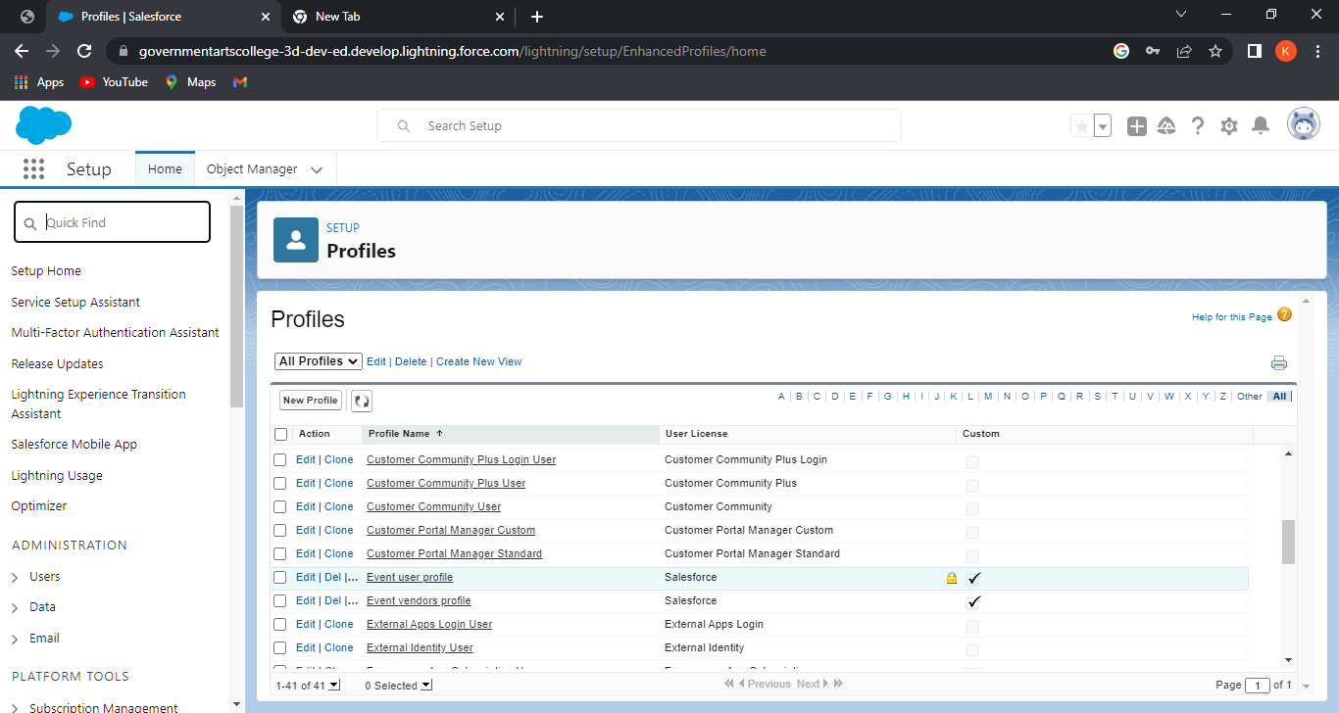

**3.2.6) Users**

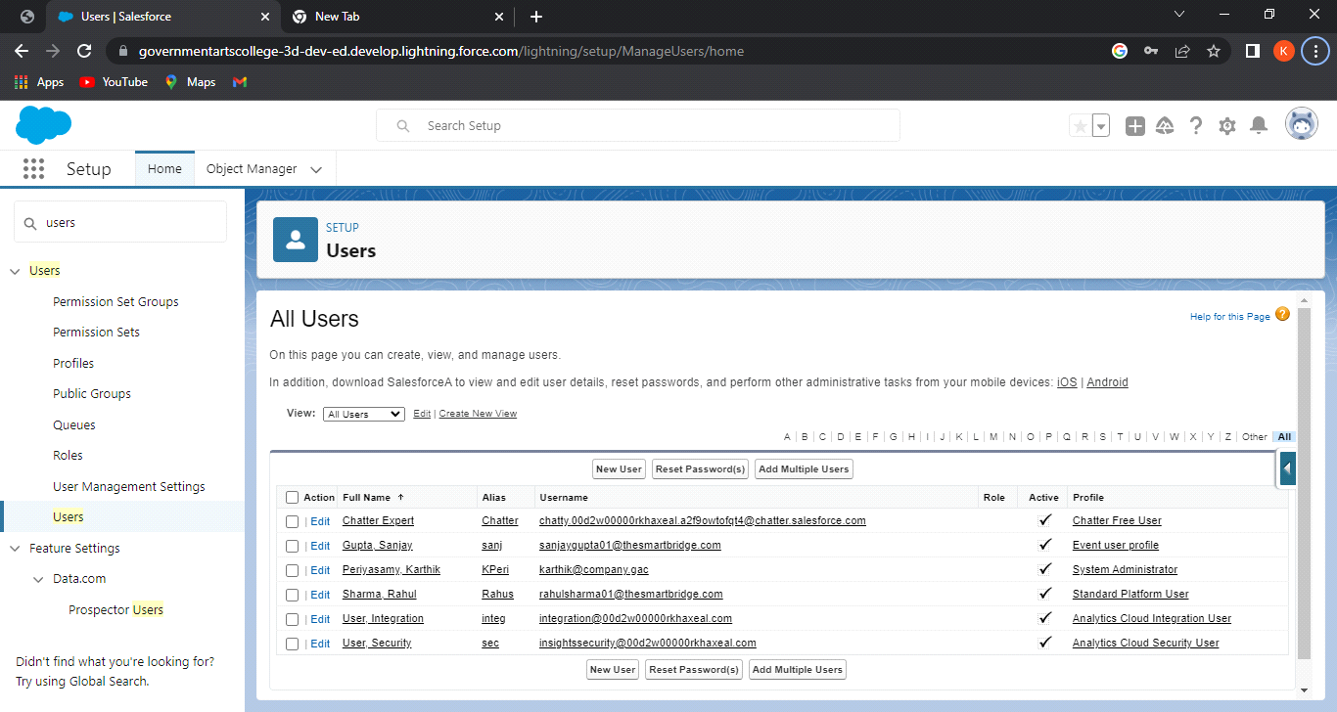

**3.2.7) Permission Set**

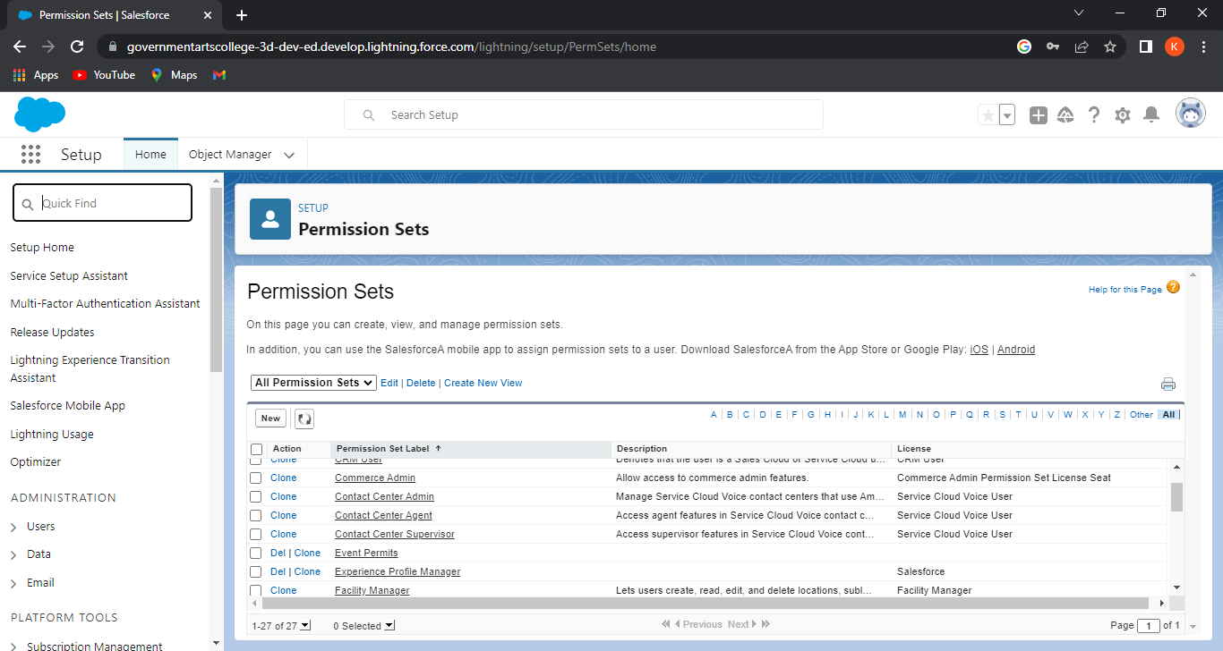

**3.2.8) Report**

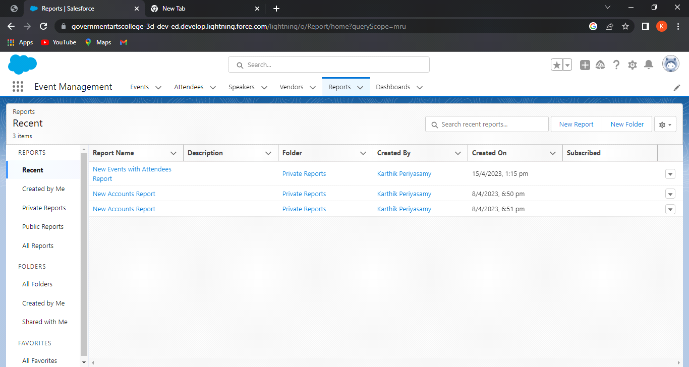

**4. Trailhead public profile URL**

**Team Lead-** [**https://trailblazer.me/id/karthikp0207**](https://trailblazer.me/id/karthikp0207)

**Team Member 1-** [**https://trailblazer.me/id/ananthananth26**](https://trailblazer.me/id/ananthananth26)

**Team Member 2-** [**https://trailblazer.me/id/beemakg14**](https://trailblazer.me/id/beemakg14)

**Team Member 3-** [**https://trailblazer.me/id/kkanth55**](https://trailblazer.me/id/kkanth55)

**5. Advantages & Disadvantages**

**Advantages**

Attracting more prospects and clients from exhibitions and trade shows

Improving brand positioning through professional events and conferences

Saving valuable time, efforts and money when hiring experience event managers

Gaining more experience for your business internal public relation and marketing teams when collaborating with professional event planning companies

**Disadvantages**

The first disadvantage and probably the biggest one of energy conservation is nature itself.

Many organization decide to use alternative energy but then back out right away due to the high cost that they will bear

Unconditional working hours

**6. Application**

The main objective of the Event Management System is to manage the details of Event,Employee,Booking,Venue,Package. It manages all the information about Event, Enquiry, Package, Event. The project is totally built at administrative end and thus only the administrator is guaranteed the access.

Consider the implementation options.

Handling all permissions, permits, insurance and security concerns

Saving valuable time, efforts and money when hiring experience event managers

**7. Conclusion**

It generates the report on Event, Activity, Payment.

Risk is embedded in each of these plans and their management and provides the agent to control the dynamic, evolving complex system.

The role of event and festival management on a large scale is the integration of a series of plans and their management by means of identifying deliverables and their monitoring.

**8. Furure Scope**

Using Lightning Web Component, and developers can develop this application in a more efficient way.

Incorporating a consumer complaint section where people can get help from the authority quickly.

Providing a platform for the event managers in the city to publish and advertise their events and also sell their products